Assignment 2-Quadratic Equation Solver Report

In this assignment, I tried to understand the requirements before I start designing this program, there are several points like quadratic equation, discriminant, roots, real part and imaginary part. I did some study during this project, include understanding of quadratic equation, print the sign integers using “%+d”, print fixed-point format with four digits after the decimal point using“%.4f”.

About the quadratic equation, there are three conditions below:

1. Discriminant > 0 : the real roots
2. Discriminant == 0 : the multiple roots
3. Discriminant < 0 : the complex roots includes the real part & image part. To use sqrt in c program, it needs positive number, therefore, it should be like this(sqrt(-discriminant)) because the discriminant is negative, the “i” also add into the image part.

For the pretty printing format, I use “if , else if, else” statement to determine the coefficient whether it is 0 or not, 1 or -1, and print the quadratic equation. Besides, I also add the check mechanism for “a” coefficient, if a is 0, print “a = 0 invalid!”

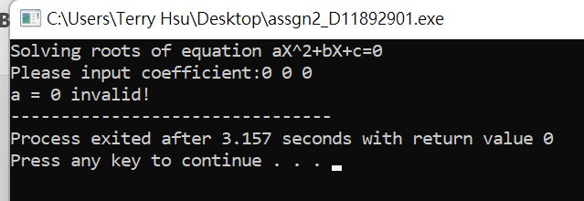

Program Results:

